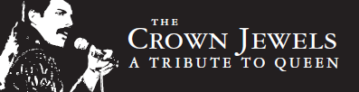
2015 Play list
One Vision
Tie Your Mother Down
Fat Bottomed Girls
Bicycle Race
Good Old Fashioned Lover Boy
Crazy Little Thing Called Love
Don’t Stop Me Now
Stone Cold Crazy
I Want to Break Free
Under Pressure
Somebody to Love
Keep Yourself Alive
Another One Bites The Dust
Killer Queen
We Will Rock You
We Are the Champions
I Want It All
I’m In Love with My Car
Play the Game
Hammer to Fall
You’re my Best Friend
Who Wants to Live Forever
The Show Must Go On
It’s A Kind of Magic
Dragon Attack
Radio Gaga
Save Me
Seven Seas of Rhye
Now I’m Here
Lazing on a Sunday Afternoon
Bohemian Rhapsody

